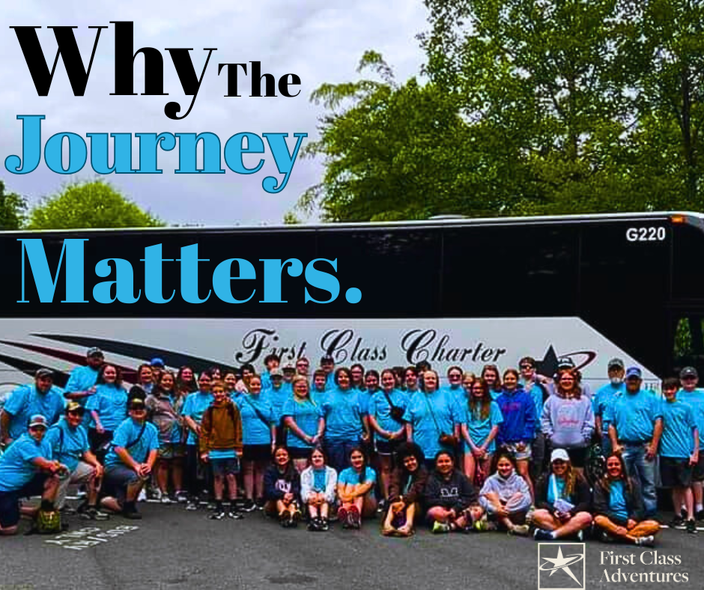
The Journey Matters: Why First Class Charter Believes in Educational Travel for Students
At First Class Charter, we’ve always believed that travel is more than just a journey—it’s an opportunity for growth, discovery, and lifelong learning. As the parent company of First Class Adventures, we are deeply committed to creating meaningful experiences for travelers of all ages. While First Class Charter provides luxury transportation for groups and organizations, it’s First Class Adventures that specializes in educational travel for students, bringing classrooms to life beyond school walls.
These students gain invaluable skills and perspectives through travel. Exploring historic cities, cultural landmarks, and science centers helps students see the world in new ways. Whether it’s walking the halls of the Smithsonian in Washington, D.C., exploring Boston’s historic sites, or diving into the vibrant arts of Nashville, First Class Adventures crafts experiences that combine learning with adventure.
Safety, comfort, and meaningful itineraries are always top priorities. Every trip is thoughtfully planned, balancing educational opportunities with fun so students can create memories that last a lifetime. Traveling as a group also builds independence, teamwork, and social skills—lessons that extend far beyond the classroom.
Kids who travel are children who grow. First Class Adventures gives students a chance to witness history, culture, and science firsthand, fostering curiosity, confidence, and a lifelong love of learning. Through these experiences, students gain a broader understanding of the world and the tools to navigate it with curiosity and care.
Ultimately, First Class Charter and First-Class Adventures share one mission: to provide safe, enriching, and unforgettable journeys. By offering our youth the opportunity to explore, discover, and learn, we invest in the next generation—because travel is not just a trip; it’s an education that lasts a lifetime.
Whether you’re a parent looking to give your child a memorable learning experience or part of an organization planning an educational trip, First Class Adventures is here to make it seamless and unforgettable. Our team will work with you to create a safe, engaging, and enriching journey tailored to your group’s needs. Explore, discover, and let learning come alive—because the world is the classroom, and every trip is an opportunity for growth.
Contact us to book your unforgettable adventure here!

https://firstclassadventures.net/

