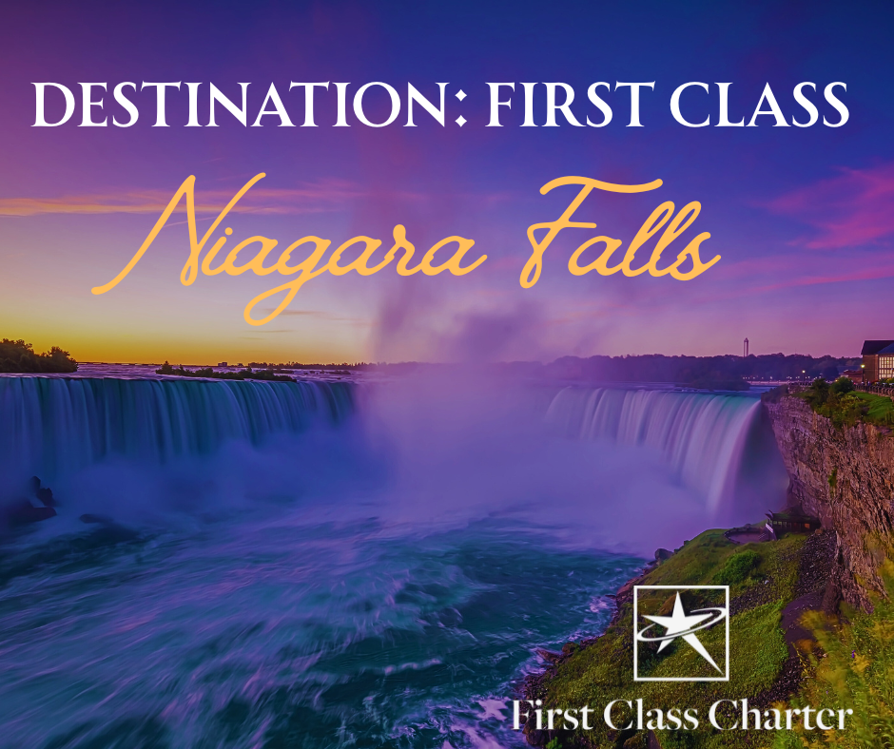
There are few places in the world as breathtaking as Niagara Falls.
Nestled on the border of the United States and Canada, this natural wonder draws millions of visitors every year—and it’s easy to see why. With its roaring waterfalls, stunning views, and endless attractions, Niagara Falls is the perfect destination for adventure, relaxation, and everything in between. And when you travel with First Class Charter, your trip becomes just as memorable as the destination itself.

Niagara Falls isn’t just one waterfall—it’s actually three: the Horseshoe Falls, American Falls, and Bridal Veil Falls. Standing near the edge, you can feel the power of millions of gallons of water crashing into the Niagara River. It’s a sight that leaves even the most seasoned traveler in awe. Whether you’re taking a boat ride on the Maid of the Mist, walking the Cave of the Winds, or snapping photos from observation decks, every moment offers a view you’ll never forget.

But Niagara Falls isn’t just about the waterfalls. The surrounding area is packed with destinations to explore. Take a scenic drive along the Niagara Parkway, where gardens, historic landmarks, and picturesque overlooks make every stop a photo opportunity. Wine lovers can head to nearby Niagara-on-the-Lake for boutique wineries and charming shops, while those seeking entertainment can explore Clifton Hill with its lively attractions, restaurants, and family-friendly fun. Whether you’re in the mood for nature, culture, or nightlife, Niagara Falls delivers it all.
Traveling with First Class Charter makes your trip even better. Forget worrying about traffic, directions, or multiple vehicles—you’ll ride in comfort and style. With spacious seating, modern amenities, and professional drivers, your journey to Niagara Falls is smooth, stress-free, and enjoyable. Imagine starting your adventure relaxed, chatting with friends or family, and arriving at the falls ready to explore. For groups, it’s the perfect way to travel together without the hassle of coordinating separate cars or rental vehicles.

From families to corporate outings or friend getaways, First Class Charter ensures everyone enjoys the ride as much as the destination. You can focus on making memories while leaving the driving and planning to experienced professionals who prioritize your comfort and safety.

Niagara Falls offers an unforgettable experience, from the awe-inspiring waterfalls to the variety of nearby attractions. And with First Class Charter, the trip itself becomes part of the adventure. Traveling in comfort makes every moment—from departure to return—memorable. Whether you’re chasing natural beauty, indulging in fun activities, or just looking for a luxurious group outing, Niagara Falls with First Class Charter is the ultimate destination experience.

Why You Should Travel with First Class Charter
Choosing how to travel can make all the difference, and First Class Charter ensures your journey is as enjoyable as your destination. With us, group travel becomes effortless, comfortable, and stress-free. From the moment you step on board, you’ll notice the difference—spacious seating, modern amenities, and a clean, welcoming environment designed for relaxation and convenience.
Our professional drivers take care of all the logistics so you don’t have to. No worrying about traffic, directions, or parking—just sit back, unwind, and enjoy the ride.
Whether you’re traveling with family, friends, or colleagues, we make sure everyone arrives safely, refreshed, and ready for the day ahead.
First Class Charter isn’t just transportation—it’s a travel experience. We focus on comfort, reliability, and customer satisfaction, making every trip seamless and enjoyable. Traveling with us means more than getting from point A to point B; it’s about making the journey part of the memory.
When you want a stress-free, comfortable, and professional travel experience, First Class Charter is the clear choice. Your next trip deserves to be effortless, enjoyable, and first-class every step of the way.

Book with us today!

FCCLuxury.com

